Filling the gaps (horseracing scalping)
He that can have patience can have what he will - Benjamin Franklin
SCALP trading, or ‘scalping’ as it’s known in the business, involves getting in and out of markets quickly and often, only taking a tick or two profit per trade. Because the profit levels are so small, scalpers need to complete a high number of trades per day to make it worthwhile. Scalpers are not after the big price moves; they just want to get their money in and out of the market as many times as possible.
When I first heard about scalp trading, I thought sounded like an easy way to make a quick buck but like most things in this game, it’s not quite as simple as it seems. Initially, I would try to predict which way the market would move and then take a position accordingly. If thought the price was going to rise, I’d lay first and then try to back at a tick or two higher and if I thought the price was going to fall, I’d back first and then try lay off my bet if I was correct. While this approach netted me plenty of successful trades, the winning trades were not earning enough to cover the losing ones and when my starting bank of a monkey (£500) had dwindled down below £50 over the space of six months, I finally admitted defeat. I was frustrated in the extreme and couldn’t work out why I was losing money but looking back, my entry points were purely based on guesswork and I do admit that my stakes were probably too large. I was trying to predict which way the market would move which is what most traders try to do - but this is completely the wrong approach to scalping and it’s also the reason why so many people lose money. A few months later I was sitting at home watching a very lightly traded market for an all-weather seller when a few ideas dawned on me. It sounds paradoxical, but I became a good scalp trader when I realised that you don’t need to know which way the market is going to move in order to make money. Let me explain….
As discussed in other chapters, a lack of liquidity in any given market can make life difficult for traders. Obviously, the bigger horseracing events such as the Cheltenham Festival and Royal Ascot are going to attract plenty of backers and layers and hence the markets will be very robust. But what about a wet Wednesday afternoon at Wolverhampton? Let's be honest, the day-to-day meetings are not always top-drawer stuff and some of these markets only come alive a few minutes before the off. At times, it can be mind-numbingly boring watching a chart or ladder which is practically standing still with very little money on each side of the book. However, these quiet periods can offer opportunities for those that have a little patience, and this 'filling the gaps' strategy actually uses the lack of liquidity as an opportunity to make money.
This strategy involves one tick scalping, and the thing I love is that you don't have to try to predict which way the market will go. You simply find a good spot to put in an initial order, then wait patiently for the price to move your way. If the price doesn't move in your direction, you can cancel the trade with no damage done. This strategy allows you to get ahead of the queue thus ensuring a good fill rate with your trades. It actually works the opposite way to most regular trades in that you pick your exit point first in this strategy.
Example one
Figure 5.0 below shows the ladder for Layla's Boy, which was running in a low-value maiden race. The market wasn't particularly strong early on and this screenshot was taken roughly eight minutes before the race went off:

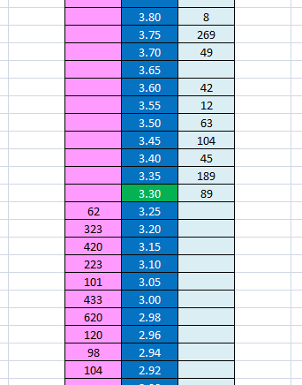
Figure 5.0
As mentioned earlier, you should always compose yourself before you trade, and take a few moments to take in what the market is telling you. So what can we tell from a quick glance at this ladder?
Firstly, we can tell that the current price of Layla's Boy is 3.30.
Secondly, we can tell that it's not a particularly strong favourite right now. A quick scan of the light-blue (back) column and also the pink (lay) column reveal that there is more money queued up to lay the horse than there is queued up to back it. While we don't necessarily need to know which way the market is going to move in order to trade this horse, it's more likely to drift if the money on the back side remains thin on the ground.
Thirdly, we can tell that no-one has an order in to back the horse at 3.65 as the light-blue box beside that price is empty. This forms the basis for our trade and 3.65 will be our exit point later on. The trick here is to get ahead of the queue by putting in a back order at 3.65 while the box is empty (as we will attempt to lay later on at 3.60). If you spot an empty box (a gap) in the market like this, follow these steps:
1. Put in an order to back the horse at 3.65. In this case, I used £100 as the stake. Be careful to use stakes that the market can easily absorb. £1,000, for example, would be completely out of place in this market and other traders would spot you a mile away. As you can see in figure 5.1, the light-blue box beside 3.65 is no longer empty as it is now displaying my unmatched £100 back order.
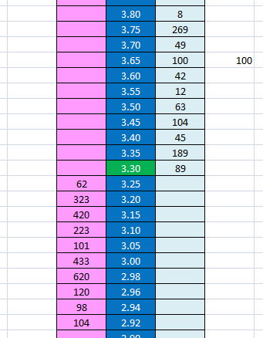
Figure 5.1
2. At this point, it's just a matter of playing the waiting game. This is where the aforementioned patience comes in to play. We are now going to sit and watch the market and wait on the price to drift up to 3.60, which is just below our order. If the price doesn’t rise, that's OK; we can scratch the trade at any time at no cost to ourselves.
3. Figure 5.2 was taken about five minutes later. As hoped, the price has now drifted up and is just below our order. Note that the market is now a lot more liquid as we approach the off and there is £554 in the queue waiting to back the horse at 3.65, £100 of which is mine. Crucially, I know that my money is first in the queue to back the horse at 3.65 as that box was empty when I put in my order earlier on:
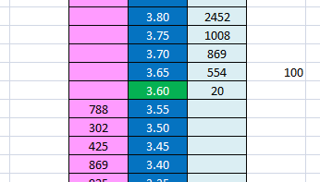
Figure 5.2
4. As the price rises, keep an eye on the money in the light-blue box at 3.60. Have your mouse at the ready - when that money starts to get eaten away, it’s time to put in your lay. In figure 5.2, there is only £20 left so now is a good time for me to click the pink box and lay at 3.60.
5. I click on the pink box at 3.60 using £100 and my lay order is submitted. I now have a back order for £100 at 3.65 and a lay order at 3.60. Figure 5.3 shows that £20 has been matched from my lay order (leaving £80 to be matched), while £10 has matched from my back order (leaving £90 to be matched). I'm now in an excellent position. My money is at the top of the queue on both sides of the book and I can be very confident that I will be quickly matched at both prices.
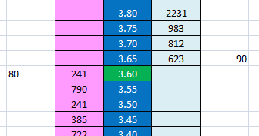
Figure 5.3
6. The rest of my order gets matched within seconds and the trade is successful.
So where does that leave me now?
- If Layla's boy wins the race: I'll earn £265 from the back bet at 3.65, but lose £260 from the lay bet at 3.60. Total = £5.
- If Layla's boy loses the race: I'll lose £100 from the back bet at 3.65, but earn £100 from the lay bet at 3.60. Total = £0
In other words, I'll earn a fiver if the horse wins the race but I won't lose any money if it doesn't. I also have the option of greening up (discussed in an earlier chapter) so I can profit no matter which horse actually wins. Fair enough, a fiver is not a huge amount of money but it only took me minutes to do this and scalping is all about turning your money over as much as possible. Pennies make pounds as they say, and it all adds up. You can also increase your stakes over time to earn more money as you gain experience and confidence.
Example two
Meetings Man was trading around 11.0 in a handicap, roughly five minutes before the start of the race. There was a reasonable amount of liquidity on that horse but there are still some gaps we can exploit.
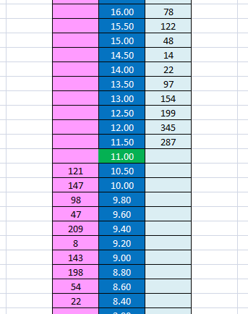
Figure 5.4
In the previous example, we found an empty price box which ensured our order was first in the queue. In this case, there are no empty price boxes (which is not ideal), but there are a number of prices with very little money beside them so it is still possible to get some scalp trades in. Have a look at the pink and light-blue columns in Figure 5.4. On the lay side, there is only £8 in the queue at 9.20. On the back side, there is only £14 in the queue at 14.50.
So in this example, I actually have an opportunity to put in orders on both sides of the book. I immediately put in an order to lay at 9.20 and another order to back at 14.50, this time using £50 as my stake (figure 5.5). As mentioned, this differs from the first example because I'm not quite first in the queue; but small sums such as £8 and £14 ahead of me should not prove troublesome.
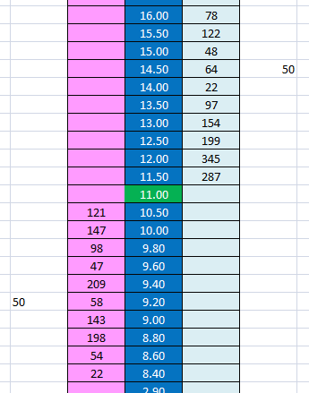
Figure 5.5
In figure 5.5, you can see that my two orders have been placed, and my money brings the amount waiting to lay at 9.20 to £58 (my £50 plus the £8 already ahead of me). Similarly, my back order at 14.50 brings the total amount of money waiting to back at that price to £64. It's now a matter of playing the waiting game. I can’t repeat this often enough: the great thing about this strategy is that we don't have to predict which way the price will go. We have orders on both sides of the book so we can just sit and wait.
As it happens, the price of the horse drops down over the next two minutes. In figure 5.6, the price is trading at 9.60, close to my lay order at 9.20:
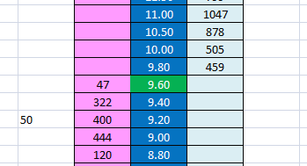
Figure 5.6
At this point, I have my finger on the mouse and I'm getting ready to back at 9.40. When I see the money getting eaten away at that price (the pink box which contains £322 at present), I will click the light-blue back button. You can see that there is now £400 looking to lay the horse at 9.20 but I'm happy in the knowledge that I’m up near the top of that queue with just £8 ahead of me.
Quite quickly, the price came down to 9.40 and I backed (using £50). At this point, I was very near the top of the queue on both sides of the book and my orders were filled within seconds. This was an interesting case as only around £80 was matched at 9.20 and then the price started to rise again. Thankfully, £50 of the £80 matched was mine; I was up at the top of the queue because I took my position early. So you can see why getting in early is crucial. Had I been at the back of that £400, my money would not have been matched and the trade would have been a loser or breakeven at best.
As the off time approached, I cancelled my back order at 14.5, happy to have completed one good trade.
So where do I stand at this point?
- If Meetings Man wins the race: I'll earn £420 from the back bet at 9.4, but lose £410 from the lay bet at 9.2. Total = £10.
- If Meetings Man loses the race: I'll lose £50 from the back bet at 3.65, but earn £50 from the lay bet at 3.60. Total = £0
What can go wrong?
On occasion, you can open a trade but then find that the market moves against you immediately and never touches your initial order. If this happens, you must get out for a one or two tick loss straight away. Remember, a successful trade will only earn you one tick at a time so this is certainly not a strategy where you leave a bad trade open and hope for the best. Be clinical. The trade either works or it doesn't and once active, it shouldn't last more than a few seconds. If you’ve entered a trade and the price is going against you, get out of the trade without hesitation. Scalping is all about getting quick small profits as often as possible so when you have a losing trade, you must get out ASAP as the margins are extremely tight. If you have problems getting out of bad trades, set an automatic stop loss (discussed in a later chapter). Another common error is actually entering the trade too early, often caused though ‘butter fingers’. Sometimes it can be difficult to sit for long periods with your finger ready on the mouse, waiting for the money to get eaten away near your price. A quick slip of the finger has often resulted in my bet going in too early and when this happens, the only option is to get out immediately. When scalping, never EVER leave a bad trade open and hope for the best. Remember, if you lose five ticks on a single bad trade because you refused to get out for a loss, you will need to have five successful trades in-a-row just to get back to even. Don't put that pressure on yourself. Take it from me – I’ve been there, wore the t-shirt - and lost the money. Letting bad trades ride is just pure gambling, and trading is not supposed to be about gambling. Just accept some small losses along the way; it's part and parcel of the game. No strategy will work 100% of the time and the sooner you accept this, the sooner you will become a good trader.
This is one of my favourite types of trade, mainly because you don't have to predict which way the market will move. You simply look for gaps in the prices, fill them, and then wait for the market to do its thing. If the market never moves in your direction, that’s fine too and you can simply cancel the trade with no money lost. The difference between this approach and regular trading is that you are actually setting your exit point first, and the entry point follows on later, should the market move in your direction. While the profits involved are quite small, it can have a very high success rate and with a bit of patience, you should find dozens of opportunities each day.

